GCP Core Services – Simple One-Sentence Explanations

1. GCP Global Infrastructure
1.1 Regions
1.2 Zones
1.3 Multi-Region
1.4 Google Global Fiber Network
1.5 Summary – Infrastructure Benefits

2. GCP Resource Hierarchy
2.1 Organization
2.2 Folders
2.3 Projects
2.4 Resources
2.5 Summary – Why Hierarchy Matters

3. IAM (Identity & Access Management)
3.1 What IAM Is
3.2 Purpose of IAM
3.3 Why IAM Matters
3.4 IAM Use Cases
3.5 IAM Key Components
- Users
- Service Accounts
- Roles (Basic, Predefined, Custom)

GCP IAM Policy Binding
- The actual rule that binds: Identity + Role → Resource

Policy Binding = Who + What Role + On Which Resource

4. Compute Services
4.1 Service Overview Table
(Compute Engine, GKE, Cloud Run, App Engine)
4.2 Compute Engine (VMs)
4.3 Managed Instance Groups (MIGs)
4.4 Google Kubernetes Engine (GKE)
4.5 Cloud Run
4.6 App Engine

5. Storage Services
5.1 Cloud Storage
5.2 Filestore
5.3 Cloud SQL
5.4 Cloud Spanner
5.5 Bigtable

6. Observability Tools
6.1 Cloud Logging
6.2 Cloud Monitoring
6.3 Error Reporting
6.4 Cloud Trace

1. GCP Global Infrastructure – Simple Explanation
What it is (Simple):
Google’s worldwide network of regions, zones, and high-speed fiber cables designed to run applications with low latency, high availability, and global reach.

1.1 Regions
Simple Explanation:
A geographical location where Google runs cloud services (e.g., Mumbai, Singapore, Iowa).
Purpose: Deploy applications closer to users.
Why it matters: Reduces latency and meets data residency requirements.
Use case: Indian payments app deploys in asia-south1 (Mumbai) for best performance.

1.2 Zones
Simple Explanation:
Independent datacenters inside a region.
Purpose: Provide fault isolation.
Why it matters: If one zone fails, apps continue in another.
Use case: Deploying VMs across Zone A & Zone B for high availability.

1.3 Multi-Region
Simple Explanation:
A distributed setup across wide geographic areas (asia, us, eu).
Purpose: Enable global, redundant storage.
Why it matters: Protects against regional outages.
Use case: Using a multi-region Cloud Storage bucket to deliver images worldwide.

1.4 Google Global Fiber Network
Simple Explanation:
Google’s private submarine and land fiber network connecting continents.
Purpose: Enable secure, fast global data transfer.
Why it matters: Ensures consistent low-latency performance globally.
Use case: Google Meet provides smooth global video due to this backbone.

Summary:
GCP’s infrastructure ensures applications run fast, reliably, and globally.

2. GCP Resource Hierarchy – Simple Explanation
What it is (Simple):
A structured way to organize cloud resources for security, governance, and billing.
Hierarchy Order:
Organization → Folders → Projects → Resources

2.1 Organization
Simple Explanation:
Top-level container mapped to your company domain (e.g., capgemini.com).
Purpose: Centralized governance and security.
Why it matters: Enforces IAM, logging, and compliance globally.
Use case: Security team applies mandatory audit logging at Organization level.

2.2 Folders
Simple Explanation:
Groups to organize projects by departments, teams, or environments.
Purpose: Provide structure and delegated control.
Why it matters: Prevents cross-environment mistakes.
Use case: Folders for Development, Testing, and Production.

2.3 Projects
Simple Explanation:
Main container for billing, IAM, APIs, and resources.
Purpose: Boundary for isolation and governance.
Why it matters: Issues in one project don’t affect others.
Use case: Telecom system uses separate projects for
- CDR ingestion
- Analytics
- Dashboards

2.4 Resources
Simple Explanation:
Actual components like VMs, Storage buckets, BigQuery datasets, GKE clusters.
Purpose: Where workloads run and store data.
Why it matters: Supports resource-level IAM and security.
Use case: A GKE cluster runs subscriber-management microservices.

3. IAM (Identity & Access Management)
What it is (Simple):
IAM controls who can access which resource in your GCP environment.
Purpose:
Provide secure, controlled access.
Why it matters:
Prevents unauthorized access and protects sensitive data.
Use case:
A Data Analyst can view BigQuery tables but cannot delete Storage buckets.
Key parts:
- Users
- Service Accounts
- Roles (Basic, Predefined, Custom)
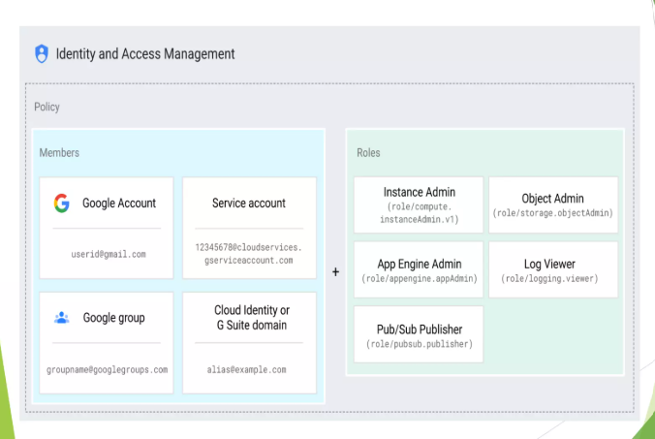

GCP IAM Policy Binding
- The actual rule that binds: Identity + Role → Resource

Policy Binding = Who + What Role + On Which Resource

4. Compute Services

4.1 Compute Engine (VMs)
What it is:
Customizable virtual machines in the cloud.
Purpose: Lift-and-shift applications without redesign.
Why it matters: Full control over OS, CPU, memory.
Use case: Running legacy on-prem applications in GCP.

4.2 Managed Instance Groups (MIGs)
What it is:
A group of auto-scaling VMs.
Purpose: Handle traffic spikes automatically.
Why it matters: Better performance and cost savings.
Use case: E-commerce app scales to 20 VMs during festival sales.

4.3 Google Kubernetes Engine (GKE)
What it is:
Fully managed Kubernetes platform.
Purpose: Deploy microservices at scale.
Why it matters: Standardized, scalable, container-based architecture.
Use case: Telecom runs 20+ subscriber microservices on GKE.

4.4 Cloud Run
What it is:
Serverless platform for containerized apps.
Purpose: Deploy APIs and microservices with no server management.
Why it matters: Scales from 0 to thousands instantly.
Use case: OTP verification API running on Cloud Run.

4.5 App Engine
What it is:
Fully managed platform for web apps.
Purpose: Focus on code, not infrastructure.
Use case: Small internal tools or simple web applications.

5. Storage Services

5.1 Cloud Storage
What it is:
Object storage for files, logs, images, backups.
Purpose: Reliable, scalable storage at low cost.
Why it matters: Handles petabytes without performance issues.
Use case: Daily CSV ingestion for BigQuery.

5.2 Filestore
What it is:
High-performance shared file system.
Purpose: POSIX-compliant shared storage.
Use case: GKE apps storing shared configuration.

5.3 Cloud SQL
What it is:
Managed MySQL/PostgreSQL/SQL Server.
Purpose: Run relational databases without managing servers.
Use case: Billing or customer account systems.

5.4 Cloud Spanner
What it is:
Global, horizontally scalable SQL database.
Purpose: Strong consistency with large-scale workloads.
Use case: Telecom or banking system requiring global consistency.

5.5 Bigtable
What it is:
Low-latency NoSQL for real-time data.
Purpose: Store massive time-series or IoT data.
Use case: Telecom network metrics every second.

6. Observability Tools

6.1 Cloud Logging
What it is:
Centralized log storage and analysis.
Purpose: Debug and audit system behavior.
Why it matters: Speeds up issue resolution.
Use case: Viewing Cloud Function logs for failures.

6.2 Cloud Monitoring
What it is:
Monitors metrics (CPU, memory, latency).
Purpose: Track system health and uptime.
Why it matters: Prevents outages via alerts.
Use case: Alert when VM CPU > 85%.

6.3 Error Reporting
What it is:
Automatically detects and groups errors.
Purpose: Identify recurring issues.
Use case: Detect repeated exceptions like NullPointerException.

6.4 Cloud Trace
What it is:
Measures latency across microservices.
Purpose: Identify slow parts of the system.
Use case: Debug slow API calls across multiple services.

